UMPIRE UNIFORM SIZE FORM

CAP:

(garrison cover size):

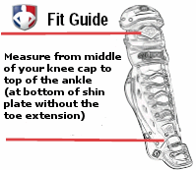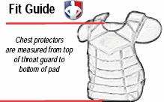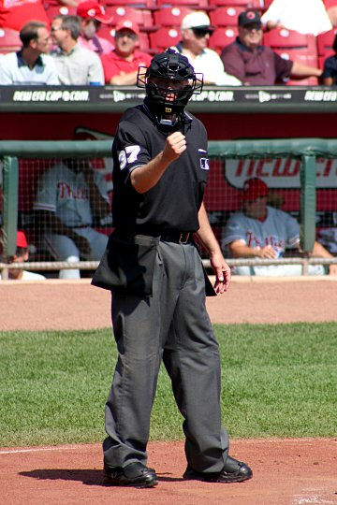

SHIN GUARDS (inches):

CHEST

PROTECTOR (inches):

MASK: **STANDARD**

WAIST:

INSEAM:

RUNNING SHOE SIZE:

**Measuring Your Inseam**  
Use a pair of pants that fit you well. Lay them flat on the ground with the side seam facing up. Use your hands to smooth and straighten front and back creases. Then measure the length of the inside seam from the crotch to the bottom of the hem.

T- SHIRT SIZE:

NAME (PRINT FIRST, MI, LAST)